SOFTWARE REQUIREMENTS SPECIFICATION

**For**

**Recipe Management System**

**Prepared by:-**

*Praanesh. S*

*Kayal Ennian. A. G*

*Mukesh. R*

# Introduction

## Purpose

## The purpose of this Software Requirements Specification (SRS) document is to define the requirements and specifications for the development of a Recipe Management System. This system aims to streamline the process of managing and sharing recipes, emphasizing features such as recipe creation, modification, deletion, ingredient management, and user interactions. The primary goal is to provide users with a platform for creating, editing, and sharing their favorite recipes, along with the ability to rate recipes for community engagement.

## Document Conventions

* + - Entire document should be justified.
    - Convention for Main title

Font face: Times New Roman Font style: Bold

Font Size: 14

* + - Convention for Sub title

Font face: Times New Roman Font style: Bold

Font Size: 12

* + - Convention for body

Font face: Times New Roman Font Size: 12

## Scope of Development Project

## The Recipe Management System is designed to be a web-based application focused on recipe creation, modification, and sharing. Users can efficiently manage their recipes, including details such as ingredients and cooking instructions. The system will also support recipe sharing, allowing users to rate recipes for community feedback. The development will utilize user-friendly interfaces and robust features to enhance the overall user experience.

## Definitions, Acronyms and Abbreviations

JAVA -> platform independence SQL-> Structured query Language ER-> Entity Relationship

UML -> Unified Modeling Language

API -> Application Programming Interface

SRS-> Software Requirement Specification

## References

* + - Books

 Software Requirements and Specifications: A Lexicon of Practice, Principles and Prejudices (ACM Press) by Michael Jackson

Software Requirements (Microsoft) Second EditionBy Karl E. Wiegers

Software Engineering: A Practitioner’s Approach Fifth Edition By Roger S. Pressman

* + - Websites

[**http://www.slideshare.net/**](http://www.slideshare.net/)

**http://www.google.com/**

# Overall Descriptions

## Product Perspective

This serves as a high-level overview of the Recipe Management System, outlining its fundamental structure. The users encompass both recipe creators and consumers, akin to staff and students in a library system. The system features a robust search functionality, enabling users to explore recipes based on diverse categories, such as recipe name or ingredients. Additionally, recipe creators can add or update recipes, contributing to the system's resource pool. Users have the ability to request actions like creating, modifying, or deleting recipes, subject to specific criteria for each operation. This ensures a dynamic and interactive experience within the Recipe Management System.

## Product Function

Entity Relationship Diagram of Recipe Management System

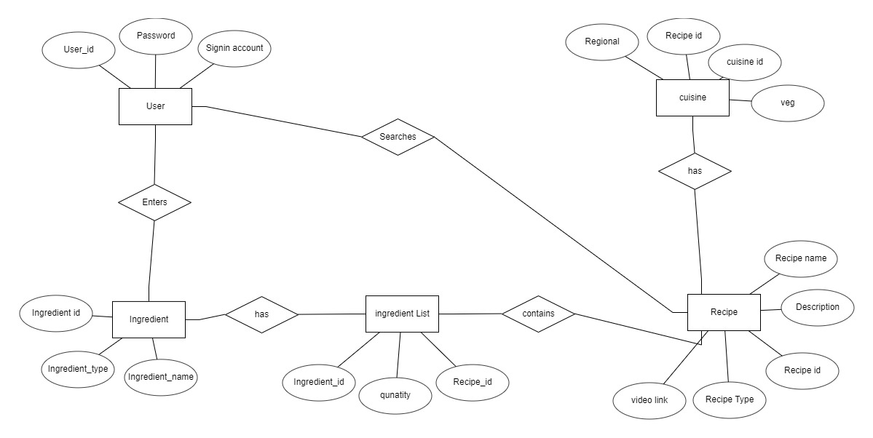

The system’s core functions include recipe creation, modification, and deletion. Additionally, users can manage ingredient lists and preparation instructions. Recipe sharing and rating features will encourage user engagement and community interaction.

## User Classes and Characteristics

The system will have two primary user classes: 1. Regular Users: They can create, edit, and delete their recipes. They can also share their recipes and rate other recipes. 2. Administrators: They have additional privileges for managing user accounts, handling reported content, and overseeing system operations.

## Operating Environment

The product will be operating in windows environment. The Recipe Management System is a website and shall operate in all famous browsers, for a model we are taking Microsoft Internet Explorer, Google Chrome and Mozilla Firefox. Also, it will be compatible with the IE 6.0. Most of the features will be compatible with the Mozilla Firefox & Opera 7.0 or higher version. The only requirement to use this online product would be the internet connection.

The hardware configuration includes Hard Disk: 40 GB, Monitor: 15” Color monitor, Keyboard: 122 keys. The basic input devices required are keyboard, mouse and output devices are monitor, printer etc.

## Assumptions and Dependencies

The assumptions are: -

* + - The coding should be error free
    - The system should be user-friendly so that it is easy to use for the users
    - The information of all users, books and libraries must be stored in a database that is accessible by the website
    - The system should have more storage capacity and provide fast access to the database
    - The system should provide search facility and support quick transactions
    - The Library System is running 24 hours a day
    - Users may access from any computer that has Internet browsing capabilities and an Internet connection
    - Users must have their correct usernames and passwords to enter into their online accounts and do actions

The dependencies are:-

* + - The specific hardware and software due to which the product will be run
    - On the basis of listing requirements and specification the project will be developed and run
    - The end users (admin) should have proper understanding of the product
    - The system should have the general report stored
    - The information of all the users must be stored in a database that is accessible by the Library System
    - Any update regarding the book from the library is to be recorded to the database and the data entered should be correct

## Requirement

Software Configuration:-

This software package is developed using java as front end which is supported by sun micro system. Microsoft SQL Server as the back end to store the database.

Operating System: Windows NT, windows 98, Windows XP Language: Java Runtime Environment, Net beans 7.0.1 (front end) Database: MS SQL Server (back end)

Hardware Configuration:- Processor: Pentium(R)Dual-core CPU Hard Disk: 40GB

RAM: 256 MB or more

## Data Requirement

## The Recipe Management System relies on crucial data elements to facilitate a user-friendly experience for recipe creation, modification, and sharing. These key data requirements encompass recipe details, user profiles, and recipe ratings. Recipe details include a unique identifier, concise description, a comprehensive list of ingredients with quantities, and detailed preparation instructions. User profiles store user names, contact information, and individual preferences such as dietary restrictions or favorite cuisines. Recipe ratings involve numeric or qualitative feedback provided by users, along with comments and additional feedback. The careful management of these data elements forms the core of the system, ensuring effective recipe management while upholding user privacy and system functionality.

# External Interface Requirement

## GUI

## A robust graphical user interface (GUI) is crucial for both users and administrators, ensuring a seamless experience. Users, including event organizers and attendees, can perform essential tasks such as event creation, updates, and detailed event viewing through an intuitive GUI. Key features of the GUI include the ability for users to generate quick reports, such as attendance metrics within specific time frames, facilitating real-time insights.

* + - The GUI is designed with customizability in mind, allowing administrators to tailor the interface to their preferences
    - The user interface must be customizable by the administrator
    - All the modules provided with the software must fit into this graphical user interface and accomplish to the standard defined
    - The design should be simple and all the different interfaces should follow a standard

template

* + - The user interface should be able to interact with the user management module and a part of the interface must be dedicated to the login/logout module

Login Interface:

The login interface for the Recipe Management System prioritizes user-friendliness, enabling unregistered users to seamlessly create accounts. Subsequently, the interface prompts users to enter their login credentials. Enhanced security measures include the display of error messages for incorrect entries, contributing to a secure access process.

Search:

Users, whether regular members or administrators, can easily search for specific recipes within the Recipe Management System. By entering keywords such as recipe names or ingredients, users can efficiently find the desired recipe. This streamlined search functionality enhances user experience and accessibility.

Categories View:

The Categories View feature provides an organized display of recipe categories available in the system. For administrators or recipe creators, this interface offers the capability to add, edit, or delete categories from the list. This ensures effective categorization and management of recipes based on distinct criteria.

User's Recipe Dashboard:

The User's Recipe Dashboard serves as a central control panel for recipe creators. Here, users can add new recipes, modify existing ones, or remove recipes they no longer need. Additionally, this control panel allows users to manage their recipe collection efficiently, providing a user-centric approach to recipe creation and modification.

# System Features

The users of the system should be provided the surety that their account is secure. This is possible by providing:-

* User authentication and validation of members using their unique member ID
* Proper monitoring by the administrator which includes updating account status.
* Proper accountability which includes not allowing a member to see other member’s account. Only administrator will see and manage all member accounts

# Other Non-functional Requirements

## Performance Requirement

The proposed system that we are going to develop will be used as the Chief performance system within the different campuses of the university which interacts with the university staff and students. Therefore, it is expected that the database would perform functionally all the requirements that are specified by the university.

* + - The performance of the system should be fast and accurate
    - Library Management System shall handle expected and non-expected errors in ways that prevent loss in information and long downtime period. Thus it should have inbuilt error testing to identify invalid username/password
    - The system should be able to handle large amount of data. Thus it should accommodate high number of books and users without any fault

## Safety Requirement

The database may get crashed at any certain time due to virus or operating system failure. Therefore, it is required to take the database backup so that the database is not lost. Proper UPS/inverter facility should be there in case of power supply failure.

## Security Requirement

* + - System will use secured database
    - Normal users can just read information but they cannot edit or modify anything except their personal and some other information.
    - System will have different types of users and every user has access constraints
    - Proper user authentication should be provided
    - No one should be able to hack users’ password
    - There should be separate accounts for admin and members such that no member can access the database and only admin has the rights to update the database.

## Requirement attributes

* + - There may be multiple admins creating the project, all of them will have the right to create changes to the system. But the members or other users cannot do changes
    - The project should be open source
    - The Quality of the database is maintained in such a way so that it can be very user friendly to all the users of the database
    - The user be able to easily download and install the system

## Business Rules

## The Recipe Management System maintains secure and efficient operations through strict rules. Authenticated users with recipe creator privileges exclusively handle recipe creation, modification, and deletion. Accurate attendee information during recipe sharing ensures data integrity, and security protocols adhere to industry standards. All recipe processes comply with legal and regulatory standards, and robust access controls prevent unauthorized data access. Comprehensive logging records user interactions for auditing, and regular security audits ensure system integrity. These rules collectively foster a trustworthy and user-friendly environment for recipe activities while upholding system reliability, security, and compliance.

## User Requirement

## Users of the Recipe Management System demand an intuitive platform equipped with tools for seamless recipe creation, ingredient management, and a comprehensive rating system. Recipe creators benefit from features like ingredient tracking, modification tools, and analytics for insights into user preferences. Users look for a user-friendly recipe creation process, transparent ingredient listings, and mobile accessibility. Administrators necessitate user management tools, robust security measures, regular data backups, compliance checks, and responsive support services.

## The admin provides certain facilities to the users in the form of:-

* + - Backup and Recovery
    - Forgot Password
    - Data migration i.e. whenever user registers for the first time then the data is stored in the server
    - Data replication i.e. if the data is lost in one branch, it is still stored with the server
    - Auto Recovery i.e. frequently auto saving the information
    - Maintaining files i.e. File Organization
    - The server must be maintained regularly and it has to be updated from time to time

# Other Requirements

## Data and Category Requirement

## The Recipe Management System necessitates a robust set of data and category requirements to ensure optimal functionality. Essential data components encompass comprehensive recipe details, including names, descriptions, ingredients, and preparation instructions. User data is crucial for seamless recipe sharing, requiring secure handling of user profiles and preferences. Ingredient data includes detailed information for precise recipe creation. Security considerations involve user authentication, access logs, and encryption keys to safeguard sensitive recipe information. Key categories include an intuitive recipe creation interface, user-friendly ingredient management, efficient recipe sharing tools, and secure user access controls. Additionally, reporting features and compliance with data protection regulations contribute to the overall effectiveness, security, and user experience of the Recipe Management System. Promotional data, such as social media integration and discounts, further enhances the system's marketing capabilities. Backup and recovery protocols, along with comprehensive documentation and support, ensure the system's reliability and provide a seamless experience for all users involved in recipe creation and sharing.

## Appendix

A: Admin, Abbreviation, Acronym, Assumptions; B: Recipe, Business rules; C: Class, Client, Conventions; D: Data requirement, Dependencies; G: GUI; K: Key; L: Library, Librarian; U: User, User class and characteristics, User requirement.

## Glossary

The following are the list of conventions and acronyms used in this document and the project as well:

* + - Administrator: A login id representing a user with user administration privileges to the software
    - User: A general login id assigned to most users
    - Client: Intended users for the software
    - SQL: Structured Query Language; used to retrieve information from a database
    - SQL Server: A server used to store data in an organized format
    - Layer: Represents a section of the project
    - User Interface Layer: The section of the assignment referring to what the user interacts with directly
    - Application Logic Layer: The section of the assignment referring to the Web Server. This is where all computations are completed
    - Data Storage Layer: The section of the assignment referring to where all data is recorded
    - Use Case: A broad level diagram of the project showing a basic overview
    - Class diagram: It is a type of static structure diagram that describes the structure of a system by showing the system’s cases, their attributes, and the relationships between the classes
    - Interface: Something used to communicate across different mediums
    - Unique Key: Used to differentiate entries in a database

## Class Diagram

A class is an abstract, user-defined description of a type of data. It identifies the attributes of the data and the operations that can be performed on instances (i.e. objects) of the data. A class of data has a name, a set of attributes that describes its characteristics, and a set of operations that can be performed on the objects of that class. The classes’ structure and their relationships to each other frozen in time represent the static model. In this project there are certain main classes

which are related to other classes required for their working.

There are different kinds of relationships between the classes as shown in the diagram like normal association, aggregation, and generalization. The relationships are depicted using a role name and multiplicities.

